Điện toán đám mây

**Nhóm 6**

**Thành viên: Phạm Thị Tâm**

**Đặng Tùng Nam**

**Nguyễn Trường Đăng**

**Nguyễn Anh Văn**

**Nguyuễn Văn Đại**

Database diagram

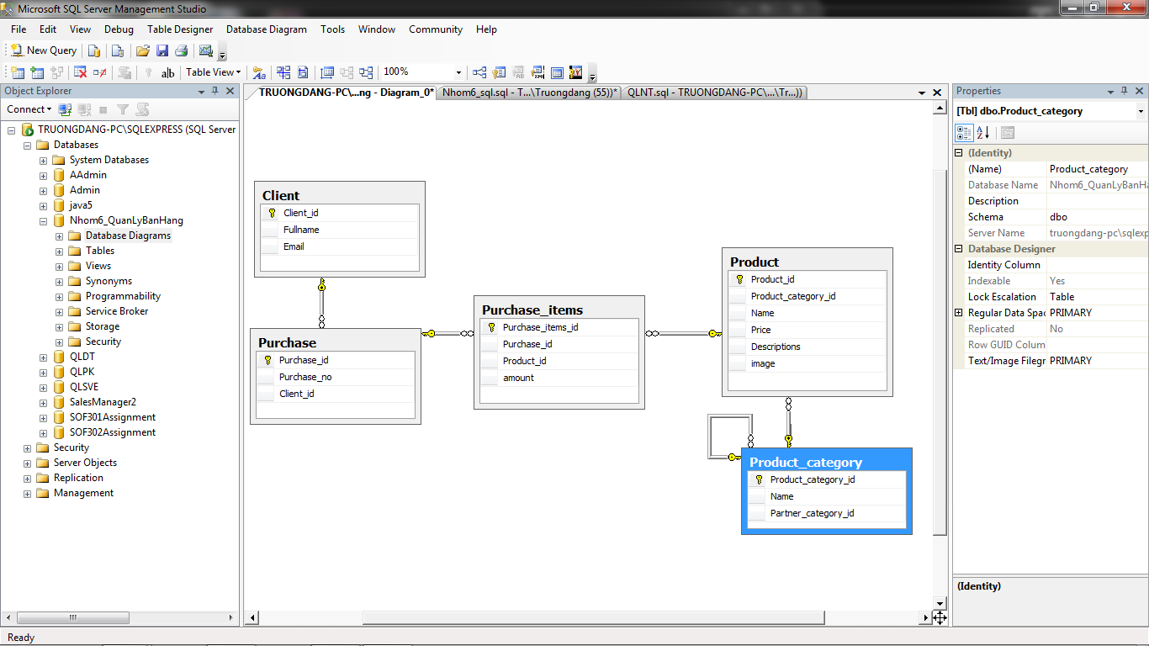

Script

create database Nhom6_QuanLyBanHang

go

use Nhom6_QuanLyBanHang

create table Client

(

Client_id int primary key,

Fullname nvarchar(30),

Email nvarchar(30),

)

go

create table Purchase

(

Purchase_id int primary key,

Purchase_no nvarchar(15),

Client_id int,

constraint FK_Purchase_Client foreign key (Client_id) references Client(Client_id)

)

go

create table Product_category

(

Product_category_id int primary key,

Name nvarchar(50),

Partner_category_id int,

constraint FK_Product_category_Product_category_id foreign key (Partner_category_id) references Product_category(Product_category_id)

)

go

create table Product

(

Product_id int primary key,

Product_category_id int,

Name nvarchar(100),

Price decimal(12,2),

Descriptions nvarchar(1000),

image image,

constraint FK_Product_Product_category foreign key (Product_category_id) references Product_category(Product_category_id)

)

go

create table Purchase_items

(

Purchase_items_id int primary key,

Purchase_id int,

Product_id int,

amount int,

constraint FK_Purchase_items_Purchase foreign key (Purchase_id) references Purchase(Purchase_id),

constraint FK_Purchase_items_Product foreign key (Product_id) references Product(Product_id)

)

go

--client

insert into Client(Client_id,Fullname,Email) values(1,N'Nguyễn Trường Đăng','dangntph04788@fpt.edu.vn')

insert into Client(Client_id,Fullname,Email) values(2,N'Đặng Tùng Nam','namdt@fpt.edu.vn')

insert into Client(Client_id,Fullname,Email) values(3,N'Nguyễn Anh Văn','vanav@fpt.edu.vn')

insert into Client(Client_id,Fullname,Email) values(4,N'Phạm Thị Tâm','tampt@fpt.edu.vn')

insert into Client(Client_id,Fullname,Email) values(5,N'Hà Phương Bảo','baohp@fpt.edu.vn')

--purchase

insert into Purchase(purchase_id,purchase_no,Client_id) values(1,1,1)

insert into Purchase(purchase_id,purchase_no,Client_id) values(2,2,2)

insert into Purchase(purchase_id,purchase_no,Client_id) values(3,3,3)

insert into Purchase(purchase_id,purchase_no,Client_id) values(4,4,4)

insert into Purchase(purchase_id,purchase_no,Client_id) values(5,5,5)

--Product_category

insert into Product_category(Product_category_id,Name,Partner_category_id)

values(1,'Nokia',1)

insert into Product_category(Product_category_id,Name,Partner_category_id)

values(2,'SamSung',2)

insert into Product_category(Product_category_id,Name,Partner_category_id)

values(3,'Iphone',3)

insert into Product_category(Product_category_id,Name,Partner_category_id)

values(4,'BlackBerry',4)

insert into Product_category(Product_category_id,Name,Partner_category_id)

values(5,'LG',5)

--product

insert into Product(Product_id,Product_category_id,Name,Price,Descriptions,image)

values(1,1,'Nokia 110i',20,'','')

insert into Product(Product_id,Product_category_id,Name,Price,Descriptions,image)

values(2,2,'SamSung Galaxy S8',499,'','')

insert into Product(Product_id,Product_category_id,Name,Price,Descriptions,image)

values(3,3,'Iphone X 256GB',899,'','')

insert into Product(Product_id,Product_category_id,Name,Price,Descriptions,image)

values(4,4,'BlackBerry Q10',99,'','')

insert into Product(Product_id,Product_category_id,Name,Price,Descriptions,image)

values(5,5,'LG V20 ',399,'','')

--purchase_items

insert into Purchase_items(Purchase_items_id,Purchase_id,Product_id,amount)

values(1,1,1,2)

insert into Purchase_items(Purchase_items_id,Purchase_id,Product_id,amount)

values(2,2,5,1)

insert into Purchase_items(Purchase_items_id,Purchase_id,Product_id,amount)

values(3,3,4,3)

insert into Purchase_items(Purchase_items_id,Purchase_id,Product_id,amount)

values(4,4,3,4)

insert into Purchase_items(Purchase_items_id,Purchase_id,Product_id,amount)

values(5,5,2,5)

select * from Client

select * from Product

select * from Product_category

select * from Purchase

select * from Purchase_items